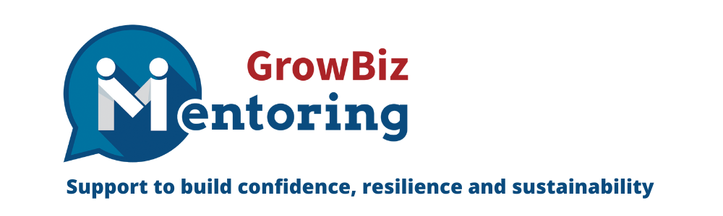
An Interview with Dave Mills

In this interview we hear from Dave Mills, who runs DMM Timber Services in the Scottish Highlands, about his self-employment journey after being made redundant and why that motivated him to volunteer to be a GrowBiz mentor:

When did you start your business and why?

I set up my business at the start of 2023. Since the early 90s I had been a senior manager for a privately owned timber business, working across the North of Scotland and employing over 200 people. In 2022 the business was purchased by an Austrian family who decided to restructure the organisation, as a result, my site at Boat of Garten was closed, and the team made redundant.

This was a very dark period for me and I was unsure where to go next in terms of my career. As part of the redundancy process, GrowBiz reached out to us in order to help employees find alternative opportunities and to consider setting up their own businesses.

This made me realise that I had developed a number of skills over the years that would be useful to other smaller businesses, and GrowBiz helped me to find a way of structuring a business plan to enable me to start up on my own offering consultancy services primarily to the timber sector.

What further support did you receive from GrowBiz and how did it help?

GrowBiz helped enormously across the first few months of setting up, from initially crafting up my business plan, help in setting up terms & conditions, pricing methods, and coaching in the use of free agent software to enable me to manage my business accounts.

The help was so invaluable I honestly don’t think I could have got to where I am almost 10 months on without their practical and simple advice.

What motivated you to then volunteer to be a GrowBiz mentor?

Over my 30-year career across the timber industry I have had the pleasure of having 2-3 really good mentors, and this is so useful in helping you at critical points in your life to share experience, and also to help guide you in areas that your business colleagues and family often don’t understand or is not appropriate to discuss with them.

The more you develop a career path, the more you realise that you can’t do things alone… and mentoring gives you the inspiration, confidence and support you need to make change and to keep making the right decisions in order to move forward. In some of the work I have done since setting up on my own, I’ve realised that this is so often a part of my work that people value the most—and frequently in their business, whether its large or small, there is sometimes no one to ask for advice or a different point of view.

So, as I’ve benefited from some of this good advice over many years, I feel now is the right point in my career to give some of this goodwill back to other people in a similar position to me, and also to the community I live in.

The Highlands are a very special place where the sense of community is not just a word, it’s actually a way of life. So I feel by offering something back to the community, that is my way of being part of something much bigger than just a job, it’s something that makes me feel like a valued member of that community, as well as helping others.

What existing skills are you looking forward to using to help others?

Helping people to have a sounding board, to listen to their challenges and to offer an opinion that might help or giving them support and confidence to pursue something that might develop either them or their business.

Over many years I’ve developed skills in all areas of business management from strategic thinking, to LEAN manufacturing, project management, and sustainability, all of which can help businesses to keep moving forward to refine what they do.

What benefits do you hope to see from the mentoring process in your own business and personal life?

As covered above, but also because it’s just a good thing to do. Helping people who value the support and guidance is just a nice thing to help with, and also helps to keep a sense of perspective and gratitude for your own position.

Why would you recommend mentoring to others?

Because it’s just the right thing to do… If you can help, why wouldn’t you?

Connect with Dave on LinkedIn here or email him at Dave@dmmtimber.co.uk

