SMN National Event Opening Addresses

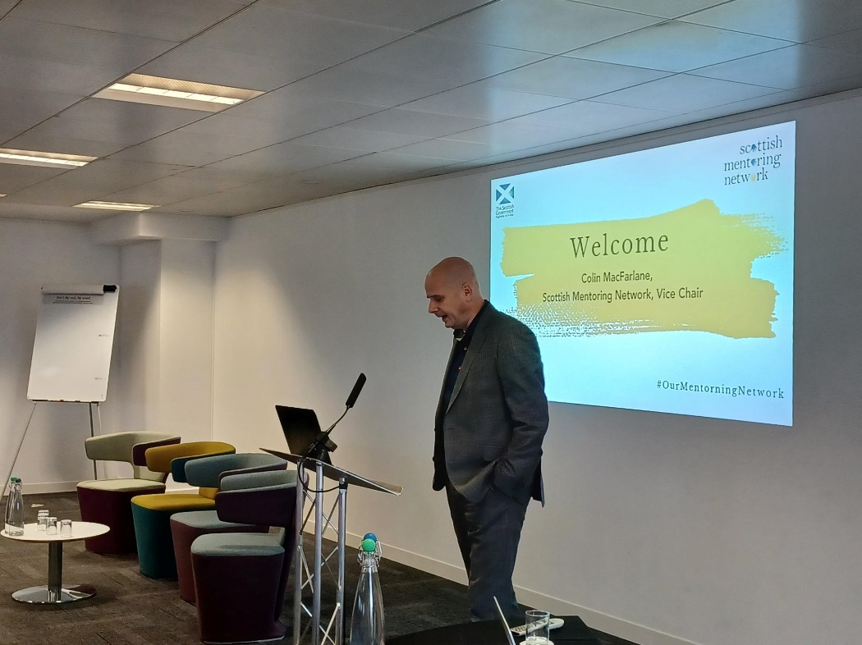
In 2023, SMN returned to the Studio in Glasgow to hold our annual conference and national networking event. We were delighted to be joined by over 65 delegates from 39 organisations, representing members from across the country. We planned the event with our members at the forefront of our minds, which helped us theme the event around #OurMentoringNetwork.
The event was opened by the Vice Chair of the SMN Board, Colin MacFarlane who welcomed the delegates to the event and reiterated the importance of working together and creating well-structured and resourced mentoring services to raise the standard and profile of mentoring.
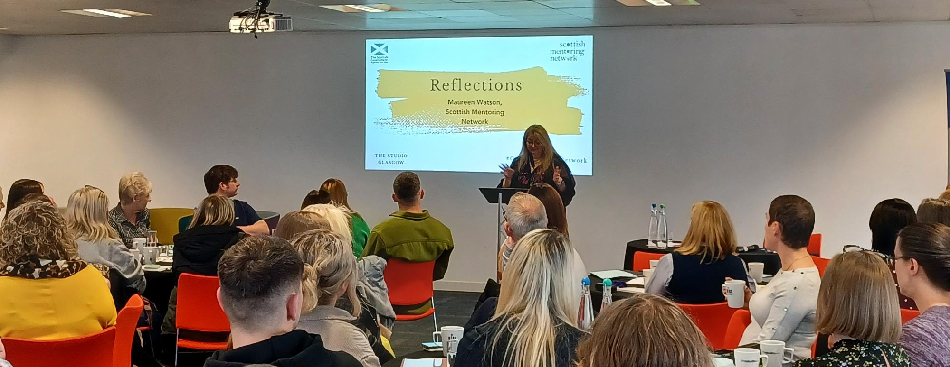
Maureen Watson, SMN’s CEO then reflected on the past twelve months at Scottish Mentoring Network, sharing her thoughts on how the network has developed and grown since the last National Event. She shared the new framework that SMN is working towards, and reflected on the opportunities and challenges that the we’ve faced. From opening up our services to mentoring organisations in England and Wales, to the continuing popularity of our training courses, Maureen celebrated the ongoing successes that we’ve had.
Maureen openly shared the difficult context for Scottish Mentoring Network, with the funding uncertainty and increased running costs that we face. She rounded up her reflections by calling on the delegates to celebrate everything that the network has to offer – the learning, the networking and the sharing opportunities.

Connecting Up

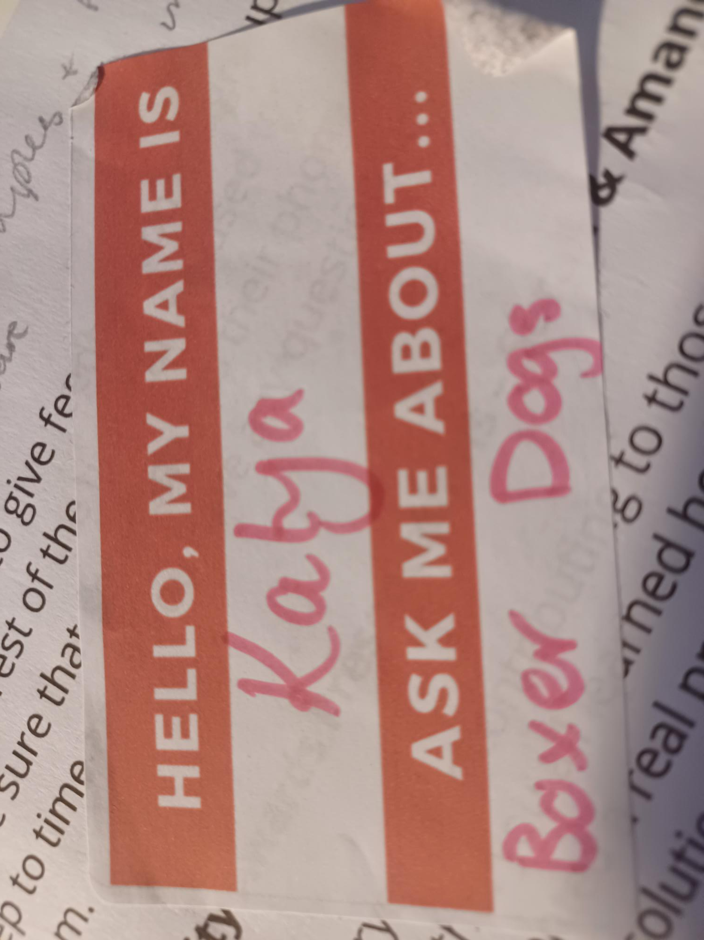
Next up, the delegates had the opportunity to connect up with each other using the name badge labels on their tables. These stickers had a space to write their name, and to write a response to the question, ‘Ask Me About…’ – the only rule was that the delegates weren’t allowed to use ‘mentoring’ for their topic to discuss.

Keynote Address

Next, Kaukab Stewart, MSP for Glasgow Kelvin was introduced by Maureen. Kaukab is the first woman of colour to be elected to the Scottish Parliament, before which she was a teacher for three decades. We have been delighted to have been supported by Kaukab through her sponsorship of our event last year at the Parliament, discussing the findings of our mapping of mentoring for care experienced children and young people.
Kaukab reflected on the times that she has acted as a mentor throughout her life, and how she will now be able to help open the door for other people who want to enter the world of politics. She remembered the times that she was supported by a mentor who helped her through challenging experiences. Her keynote was peppered with wonderful examples from fictional Mentor and Mentee relationships; from Gandalf and Frodo to the Genie and Aladdin.
She was then able to take questions from the audience about how the mentoring community can become more diverse and how the Scottish Government can work to embed mentoring provision.
Thank you to Kaukab for giving such an inspirational keynote to the delegates.
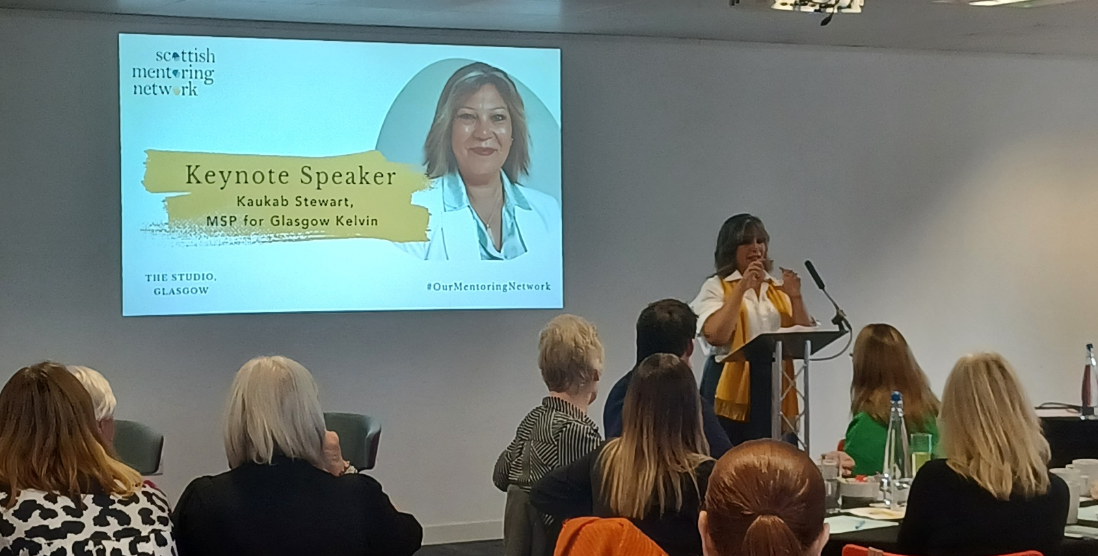

Knowledge Exchange Tables

We then moved on to the Knowledge Exchange Tables, where members of the network hosted a table to share their knowledge and expertise on a specific subject.
- Table 1: WRAP training service with GrowBiz
- Table 2: Using External Partners to enhance the mentees experience with Project Scotland
- Table 4: Using Intergenerational practice with Generations Working Together
- Table 5: Embedding Trauma Informed Practice with Move On
- Table 6: Participation: the highs and lows! With Inspiring Scotland
- Table 7: Mentoring training with Sarah from SMN
- Table 8: Developing your Mentoring Service with Amanda from SMN
It gave the delegates time to ask questions of their hosts and find out more about these specialist topics. Thank you to all our Knowledge Exchange Table hosts for sharing your knowledge with the delegates.
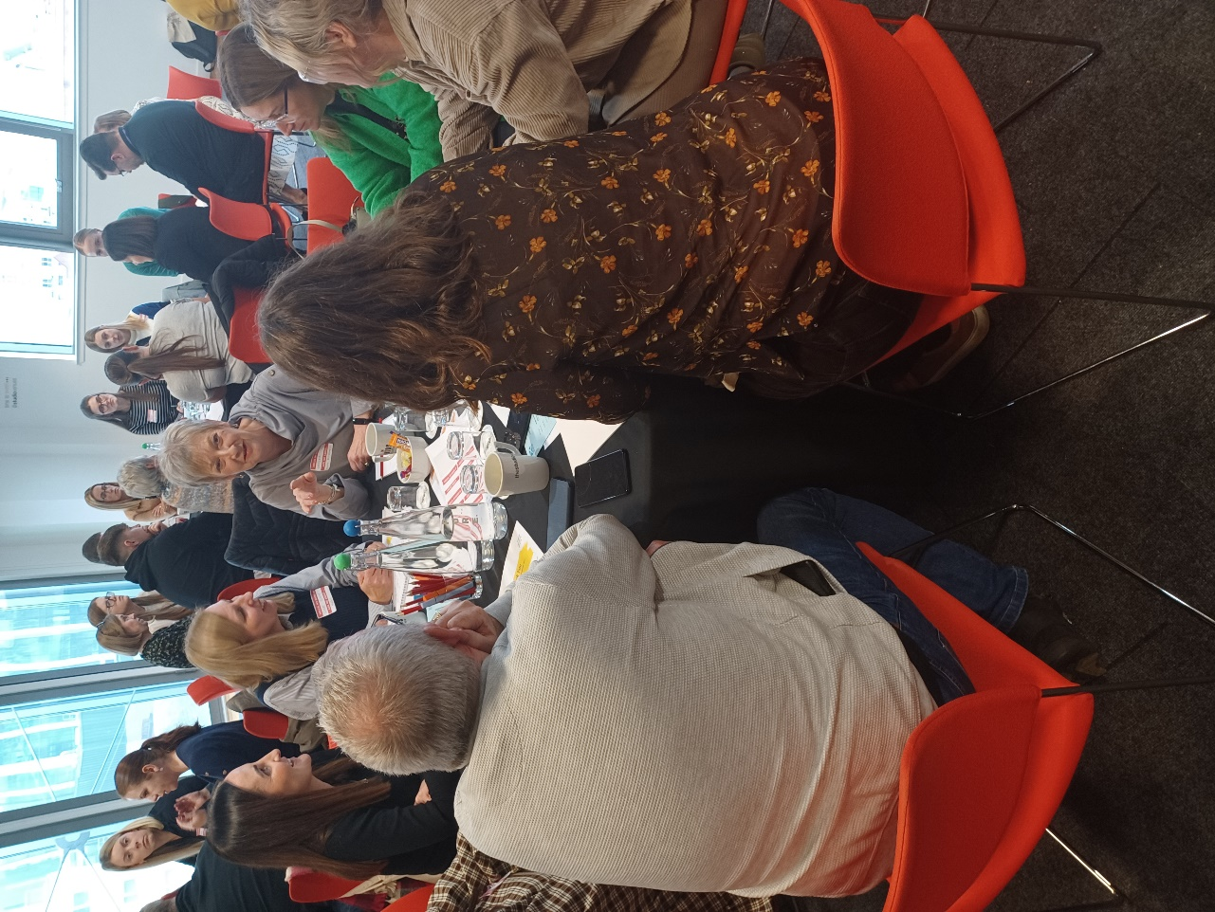
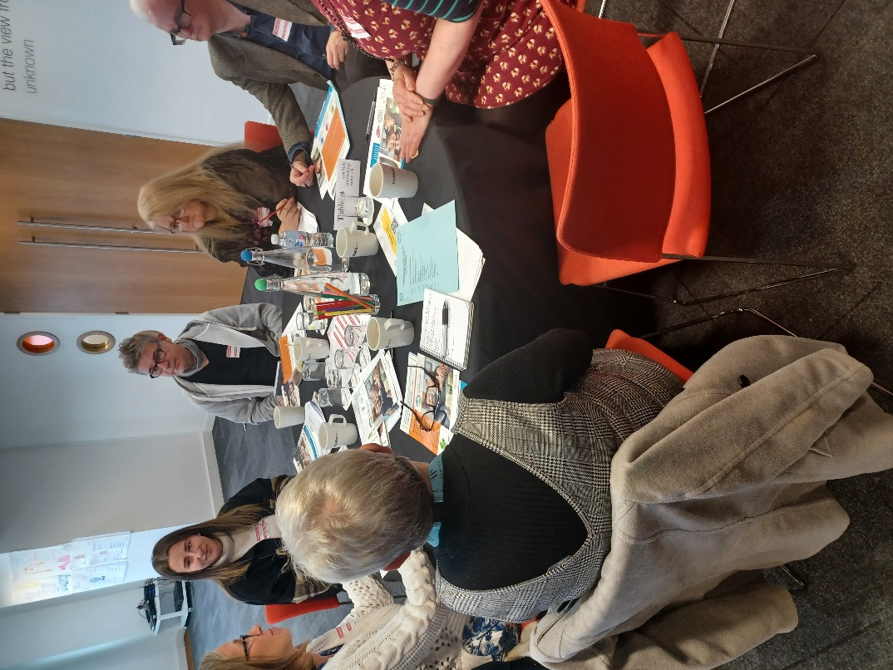

Member Q&A Panel

Next up, we held a Q&A Panel to share different experiences of how organisations can create and run mentoring services. We chose three organisations to be on the panel based on their differing relationships with Scottish Mentoring Network.
We had Rachel Bell from Scottish Prison Service College, who has undertaken the Professional Certificate in Co-ordinating Mentoring Programmes.
Sandra Hill, a volunteer mentor from Positive Changes CIC also joined us. Positive Changes undertook our Wrap Around service (now the Mentoring In Practice Service), and SMN supported the development of their mentoring service.
Our final panel member was Tony Shemwell, Operational Lead for Community Justice at the Wise Group. The Wise Group mentors are all trained using SMN’s Professional Practice Award in Mentoring.

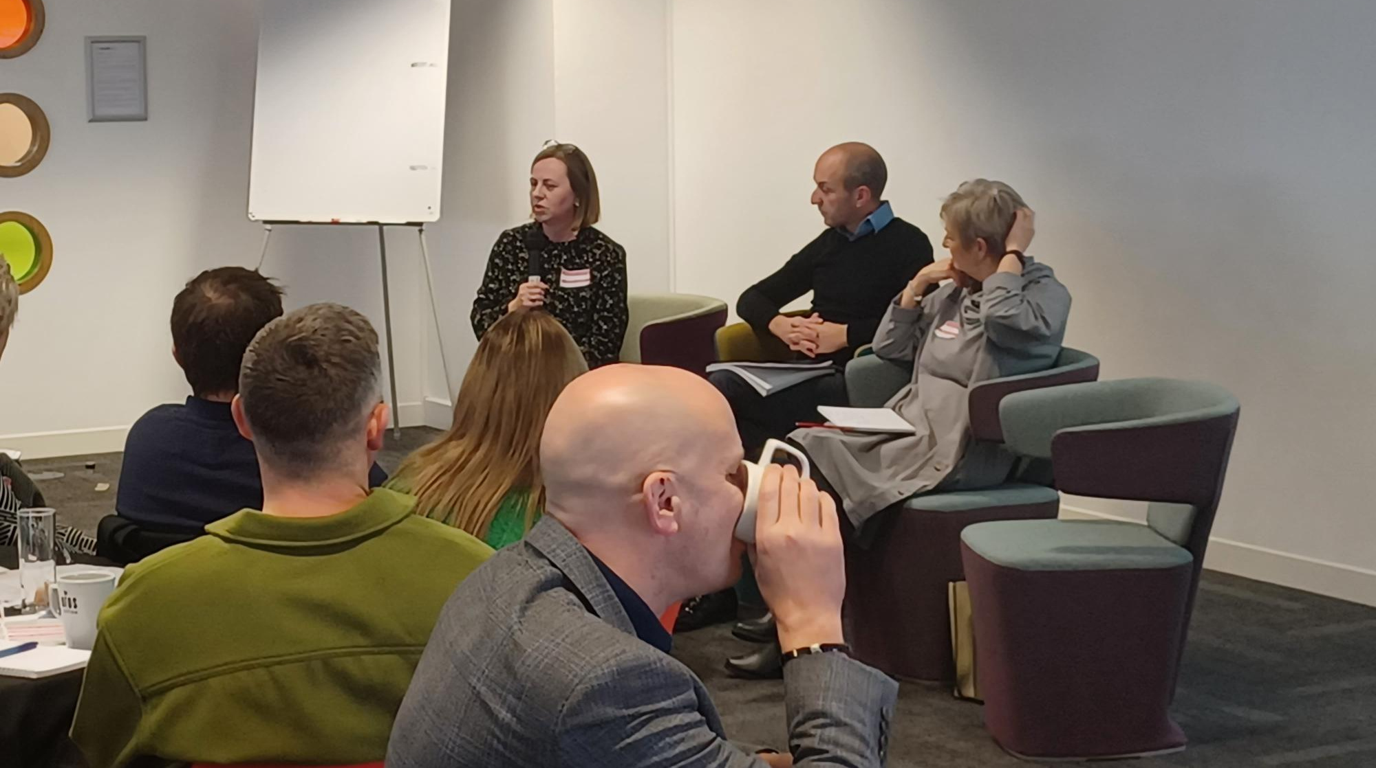

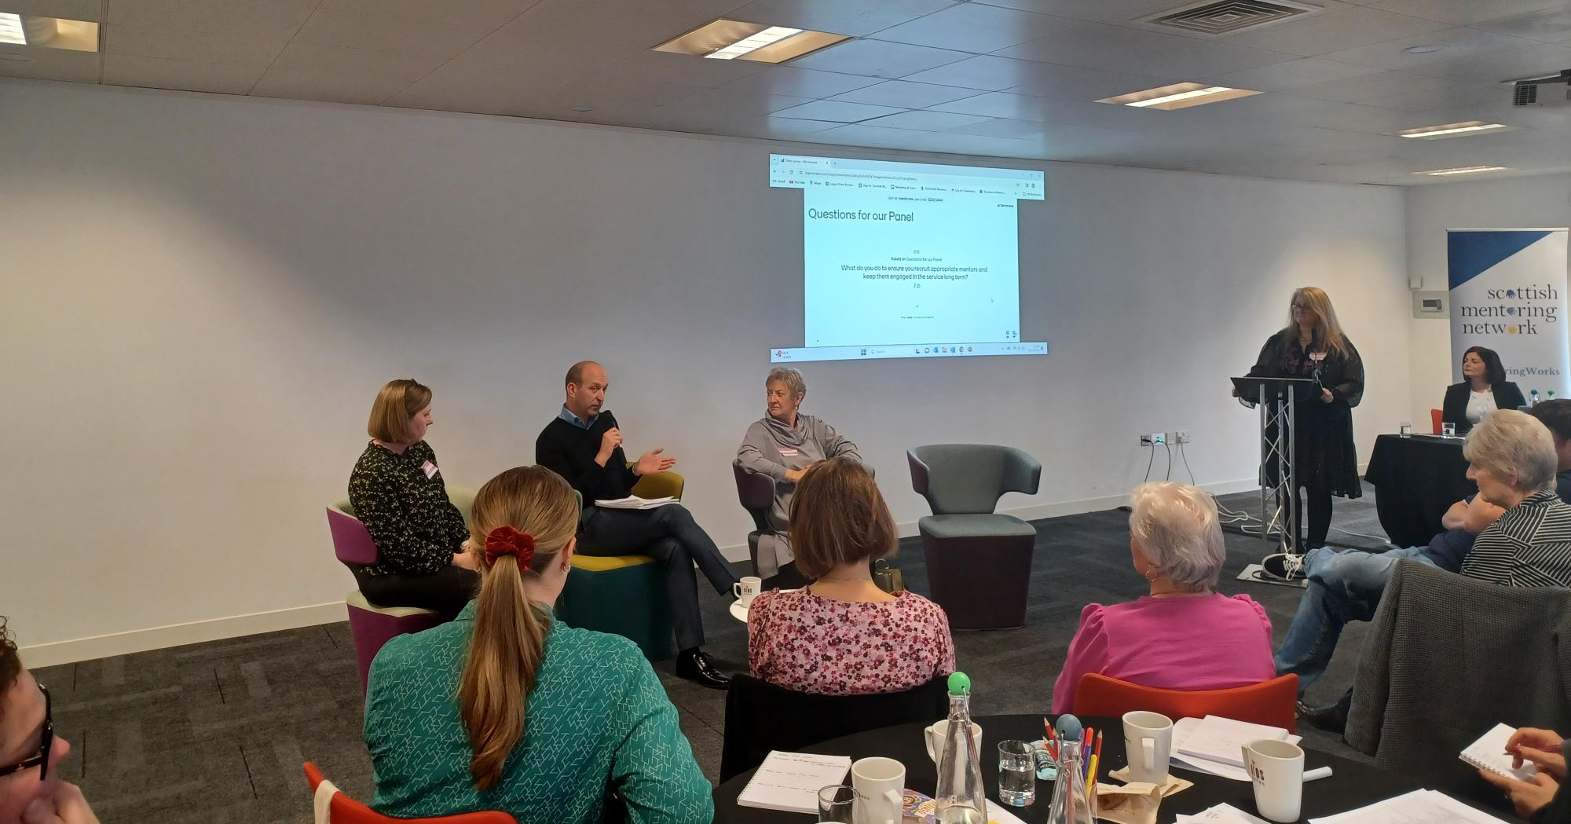

The panel members answered a range of questions from the audience, chaired by Maureen Watson. They reflected on a range of topics, from the structure of their mentoring services to the advice for new mentoring services. The panel shared their views on how best to use the support of Scottish Mentoring Network and the impact that it has had on their practices.

Action Learning Sets
After a networking lunch, the delegates were able to practice Action Learning Sets. The team at SMN decided to include Action Learning Sets to give the delegates an opportunity to try problem solving using the Action Learning Set technique. At their round tables, the delegates were given the opportunity to present their problem to be solved with the support of the group. The SMN team created sample scenarios and detailed instructions for how to use the ALS technique, so we can make these available to anyone who would like to practice Action Learning to support decision making in teams.

Quality Award Presentations

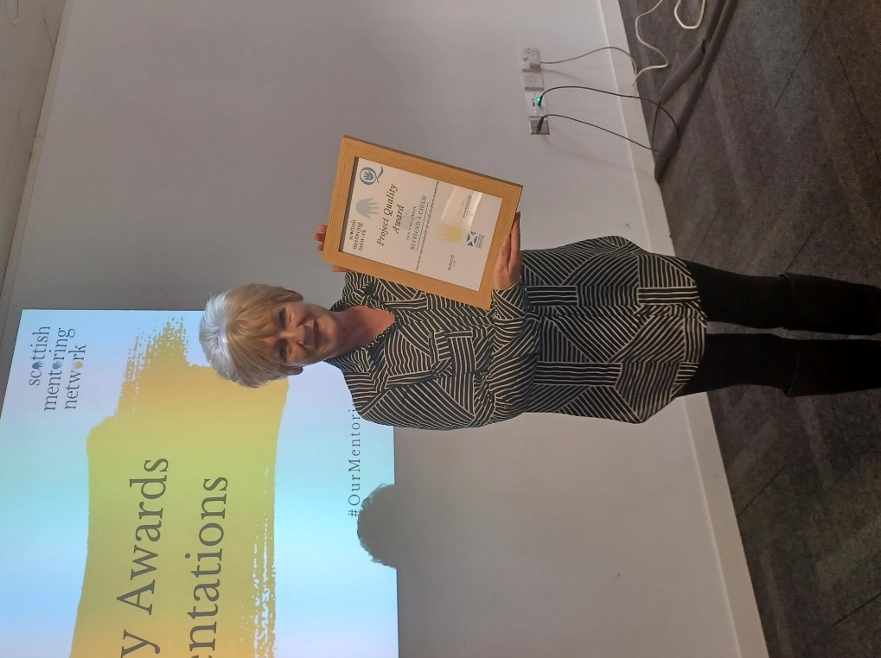
Before closing the day, Sarah Barr and Amanda Skinner-Welsh presented those attending with their certificates and shared some information about the organisations who have achieved their Quality Award. The Quality Award is an independent benchmarking service for mentoring services, helping these organisations to show to stakeholders their dedication to quality mentoring practices.
They also presented a special award to our member, Move On. Move On have now continuously held the SMN Quality Award for 10 years. We wanted to recognise this fantastic achievement by presenting the team with a special award. Congratulations to all of the Move On team for reaching this milestone!
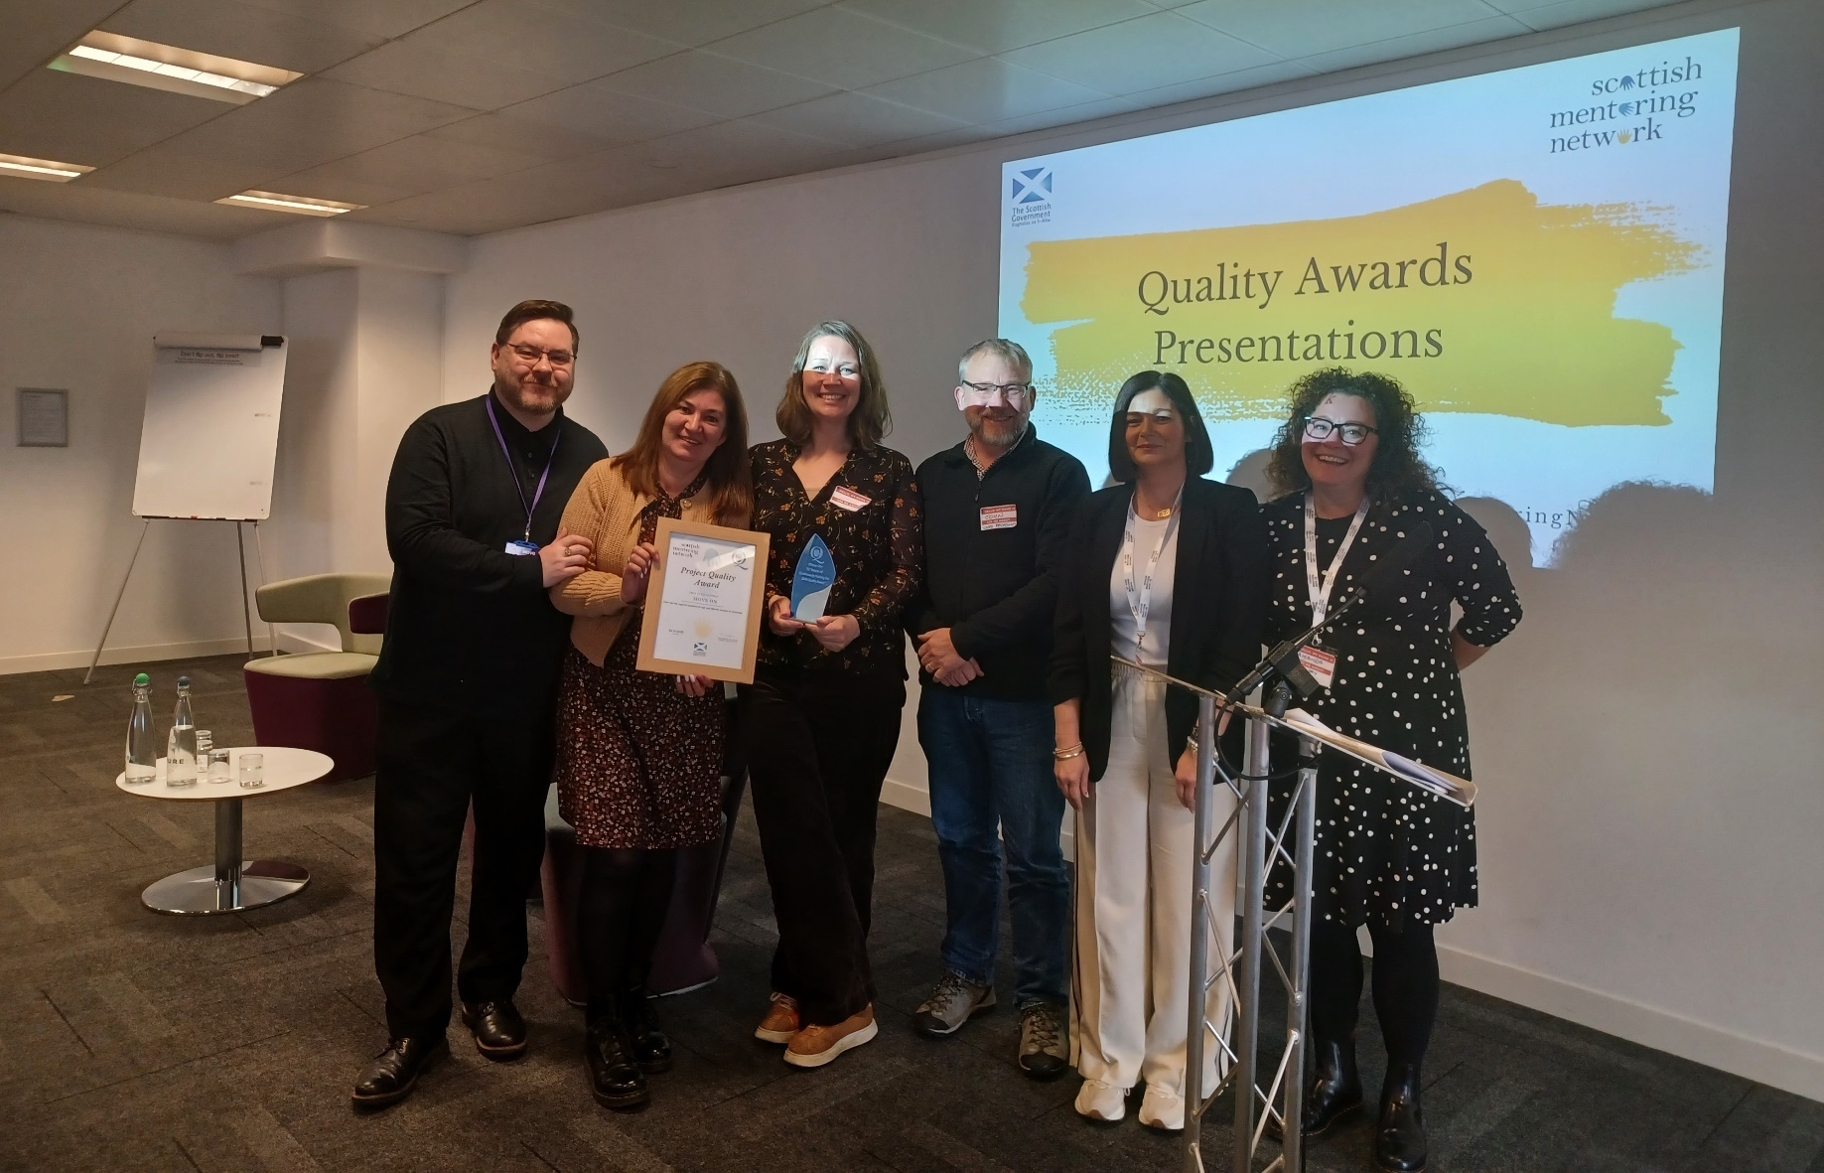

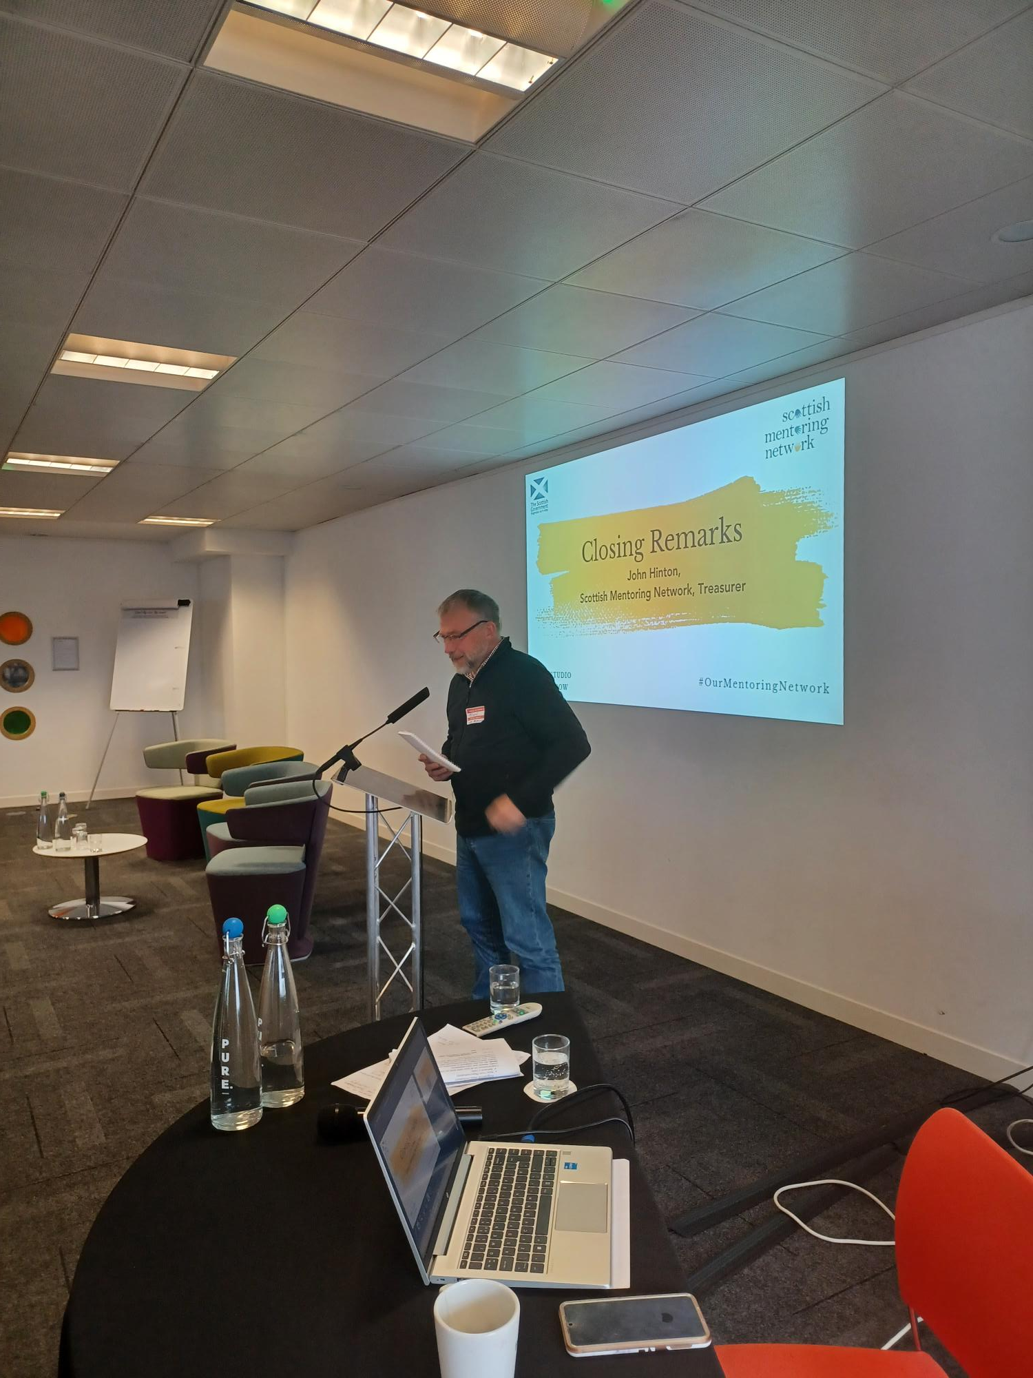

Closing Remarks

We ended the day with some closing remarks from our treasurer John Hinton. He thanked the delegates and the SMN team and shared his reflections on the importance of the connections that are made throughout the network.
We would like to thank all the delegates who came along and everyone who contributed to the SMN National Event 2023. As a parting request, we asked the delegates to tell us what #OurMentoringNetworks means to them. Here are their responses.

Solidarity in promoting the impact of mentoring + ensuring high quality support meets more + more people
Community
Loved
Credibility
Shared connections
Support
Advice
Wisdom
Peer Support + Sharing experiences
Encouragement and a boost to keep going!
Getting out of the thick of it for a bit to give us time to reflect and make new connections with like minded people
Support & Information
Connections with like minded organisations
Continued Support
Sharing best practice
